Europass  Curriculum Vitae |  | 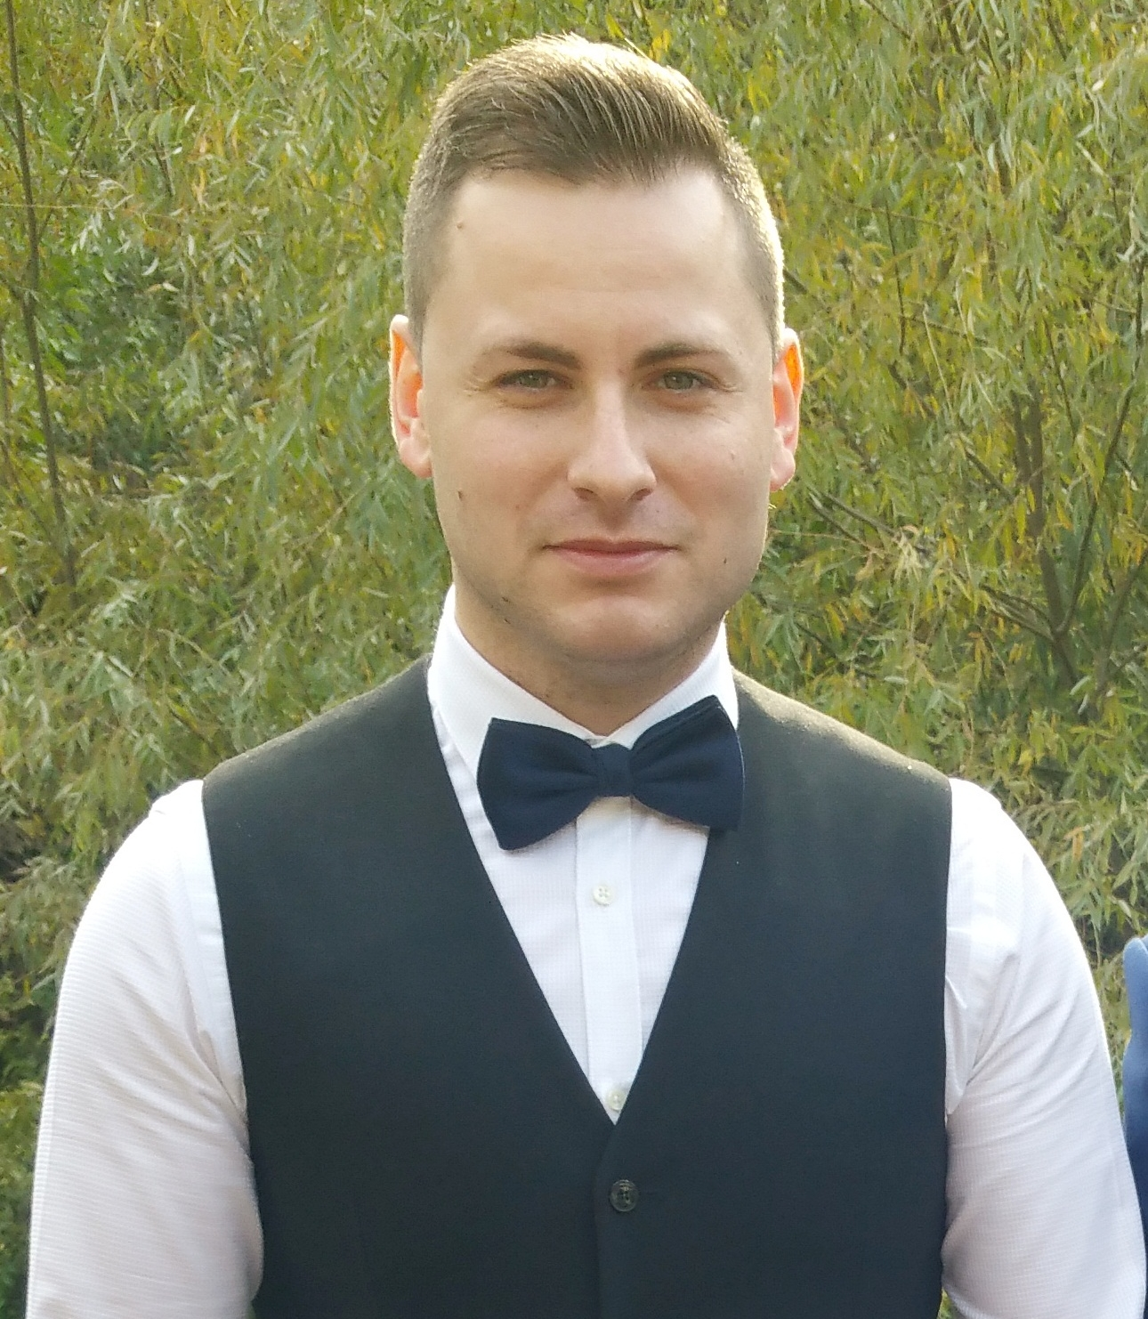
Personal information
First name(s) / Surname(s) |  | ALEXANDRU DRAGAN
Address(es) |  | SABINELOR STR. , NR 29, BL C9,SC B,AP43. ROMANIA
Telephone(s) |  | Mobile: |  | +40752 509 584
E-mail |  | alecsu00@yahoo.com
Nationality |  | Romanian
Date of birth |  | 31.July.1989
Gender |  | Male
Occupational field |  | BARTENDER/BARISTA
Work experience |  | - Bartender  - Bar/Waiter  - Barista  - Bartender/Barista  - Bar/waiter  - Bar/waiter  - Bartender/Waiter  - Bartender  - Bartender/Waiter  - Bartender/Waiter/Assistant Cook  - Bartender
Dates |  | - January 2018 – Present  - April 2017- Octomber 2017  - April 2016-April 2017  - September 2015-April 2016  - December 2014- August 2015  - November 2013- August 2014  - June 2012 - November2013  - March 2012- May 2012  - May 2009-March 2012  - February 2009-May 2009  - Octomber 2008-February 2009
Main activities and responsibilities |  | Experienced,hardworking, trustworthy, and dependable bartender seeking a position with advancement opportunities where I can utilize my energy, creativeness and multitasking abilities in order to make money for my establishment. Over 6 years of experience as a Bartender.I worked in clubs , coffe & lounge places ,Cruise Ships and now in a 4* Hotel. My overall duties included mixing liquor, soft drinks, wine, water and other ingredients to prepare cocktails and other beverages and serve in their proper glasses, cash handling, products management, serving drinks, promote products, teamwork, workplace organizational interactive communication, improve service quality, inventory of goods I performed closing and opening duties, along with assisting the customers, operating the cashier register, training new employees.
Name and address of employer |  | - ROYAL CARIBBEAN INTERNATIONAL (CRUISE SHIPS : NAVIGATOR OF THE SEAS)  - ROYAL CARIBBEAN INTERNATIONAL (CRUISE SHIPS : RADIANCE OF THE SEAS)  - FILICORI ZECCHINI  - DELTA COFFE & LOUNGE 4* HOTEL  - NORWEGIAN CRUISE LINE (CRUISE SHIPS NORWEGIAN STAR)  - NORWEGIAN CRUISE LINE (CRUISE SHIPS NORWEGIAN SKY)  - PUB DEEPER)  - THE CORNER COFFE &LOUNGE)  - DEEP CLUB )  - DEEP 3 RESTAURANT)  - DEEP 2 PUB
Type of business or sector |  | - COFFE&LOUNGE  - HOTEL 4*  - FOOD & BEVERAGES CRUISE SHIPS  - BAR/PUB  - COFFE&LOUNGE  - BAR/NIGHT CLUB  - BAR/RESTAURANT  - BAR/PUB
Education and training |  | - Barista School  - STCW-95 Basic Safety Norwegian Cruise Line  - Forming School  - HIGH SCHOOL
Dates |  | - February -2017  - January 2014  - 2009- 2010  - 2004-2008
Title of qualification awarded |  | Barista Basic Diploma  STCW-95 Basic Safety  Bartender Diploma  High School Diploma
Principal subjects/occupational skills covered |  | Introduction To Coffe ,Brewing,Barista Skills.  Personal survival Techniques,Elementary First aid,Personal and Social Responsibilities  Bar and Restaurant rules of preparing and serving drinks.  Tourism
Name and type of organisation providing education and training |  | Speciality Coffe Association Of Europe SCAE  Norwegian Cruis Line  Regional Forming School Calarasi.  Cultural Foundation of Constanta.
Personal skills and competences |  | Creativity,cooperation,discipline,attention to details,positive attitude,optimism,order,stability,energy,stress rezistent,practical spirit,leadership.
Mother tongue(s) |  | Romanian
English  Spanish |  | Advanced (Read/write/Speak)  Begginer (Read/write/Speak)
Social skills and competences |  | Extremely organised person,problem-solving attitude, responsibility,teamwork.
Organisational skills and competences |  | Attention to details,multi-tasking,leadership, adaptability,flexibility, dedication,hard-Working, positive attitude,motivation,energy,passion.
Technical skills and competences |  | Analytical,Research Skills ,Computer,Technical Literacy.
Computer skills and competences |  | Excelent computer skills in  Editing: Microsoft word,Microsoft Power Point.  Databases : Microsoft Acces,MicrosoftExcel.  Photo Editing: Corel Photo Paint, Adobe Photo Shop.  Pc Operation Systems : Winsdows Xp,Vista,7.  Technical and Practical Abilities in Desk Equipment.
Artistic skills and competences |  | Music ,graphic designer.
Other skills and competences |  | Interpersonal Abilities,multicultural sensitivity awareness, planning,organizing, honesty,Integrity,morality willingness to learn.
Driving licence |  | Romania. Category B since November 2007.

